**Purple Team: Dylan Bonis, Robert Duvall, Melinda Guthman, Meg Kellenberger** :

12/4/22, Module 9 Assignment, Willson Financial

**Initial ERD:**

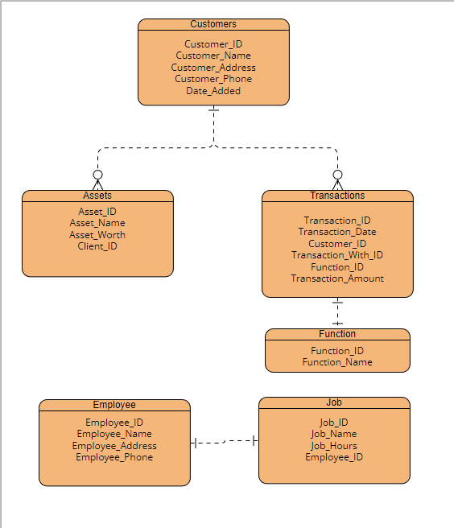

**3NF:**

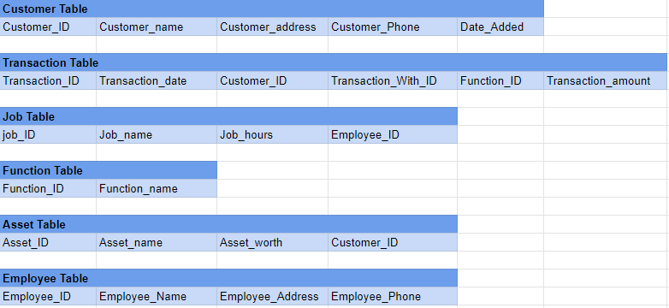

**Business Rules:**

Each Customer can have multiple Assets

Each Customer can have multiple Transactions

Each Transaction has one Function Type

Each employee has one Job

**Assumptions:**

As the business itself would need a record of employees, despite it not being needed for the business questions, it would be a necessary part of the database.